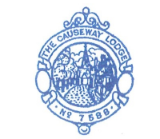

CAUSEWAY LODGE (No.7588)

Progressive Offices
Progressive Office refers to a series of appointments within the lodge, culminating in the office of Master. Ideally, a mason starts at the most junior office and "progresses" to the next in line each year, or every two years. The typically sequence is Steward, Inner Guard, Junior Deacon, Senior Deacon, Junior Warden, Senior Warden, Master. Progression to Worshipful Master is NOT always done by "moving through all the chairs", but every Master must have served for one year as a Warden. .
Every Lodge has Principal Officers (Master, Junior Warden, Senior Warden) and Assistant Officers (Tyler, Inner Guard, Junior deacon, Senior Deacon.
All Officers are defined in our Book of Constitutions.
Regular Officers (Master and his two Wardens, a Treasurer, a Secretary, two Deacons, an Inner Guard and a Tyler) – “Regular” in this sense means as defined in the Constitution and under the authority of the Warrant of the Lodge issued by UGLE.
Additional Officers (Almoner, Charity Steward, Chaplain, Director of Ceremonies, Lodge Mentor, Assistant Director of Ceremonies, Organist, Assistant Secretary and Stewards but no others).
No Brother can hold more than one Regular Office in the Lodge at one and the same time, but the Master may appoint a Brother who is holding a Regular Office to one Additional office also. Any member who is not in a Regular Office may hold more than one Assistant Office concurrently.

Worshipful Master

Jewel of the Worshipful Master
The senior officer of a Masonic Lodge is the Master, normally addressed and referred to as the "Worshipful Master" (WM). His place in the East of the lodge room, wherefrom he manages the business of his lodge, and is vested with powers limited by the Constitution and the by-laws. He presides over all rituals and ceremonies in the lodge, and at Committee meetings.
The office of WM is the highest honor to which a lodge may gift to it members. The office is filled annually by election, by secret ballot if there is more than one nominated candidate for the chair. The requirements as to the character and abilities of the Master are embedded in the Constitution and the Installation Ritual. In practice, most lodges will nominate and elect the previous year's Senior Warden in an uncontested election.
Let’s be clear about this - The honorific "Worshipful" does not suggest that the Master is worshiped in any way, but is used in its original meaning, "worthy of respect". (Mayors and magistrates are also traditionally called "Worshipful" or "Your Worship", as are certain Officers in the Livery Companies.
At the conclusion of his twelve-month limited term of office, a WM is termed a Past Master (PM). He becomes the Immediate Past Master (IPM) until another member takes his place. A WM may only serve up to two terms successively unless specifically so-authorised to continue in Office by a letter of Dispensation from his Provincial Grand Lodge (PGL) and the United Grand Lodge (UGLE).
With the proviso of at least a year’s break between appointments, there is no limit on how often a member may be WM of his lodge, or indeed of any other lodge – however, he is not permitted to be WM of more than one Craft Lodge (i.e. one conferring the first three Degrees) concurrently, unless, again, by Dispensation.

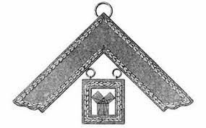
Immediate Past Master
Jewel of the Immediate Past Master
The IPM is the prompter for the WM, so close liaison with the WM and the Director of Ceremonies (DC) is vital to smooth the flow of ceremonies.
The jewel is worn by all PMs until they receive higher ranks from PGL or UGLE. It represents one of the secrets of geometry preserved in ancient freemasonry.It is variously described as The 47th Problem of Euclid, or the 47th Proposition of Euclid, or the Pythagorean Theorem, or Pythagoras’s Theorem – it is represented by 3 squares around a triangle.
All PMs retain the honorific "Worshipful" (e.g. "Worshipful Brother Smith, but oddly the IPM is not listed as an Officer of the Lodge – thus he may undertake other lodge duties.
If a WM falls seriously ill or dies, then the IPM typically stands in as ”Acting Master” until the next election in the lodge.

Senior Warden
Jewel of the Senior Warden
The Senior Warden (SW) is the second of the three Principal Officers of a lodge, and he the Master's principal deputy should the Master not be able to attend committee meeting etc. However, only an Installed Master i.e. a Past Master may confer Degrees, so an experienced member would take the chair from the SW to do so. Thus, if the WM is absent then the SW may preside at meetings and may act for the Master in all matters of lodge business, but the SW can only fully fill this role if he is also a Past Master. In many lodges it is presumed that the SW will become the next WM, and he is appointed by the current WM.

Junior Warden
Jewel of the Junior Warden
The third of the Principal Officers is the Junior Warden (JW) who is metaphorically charged with the supervision of the Lodge while it is "at refreshment" (for meals or other social purposes). He has a particular responsibility for ensuring that visiting Masons are entitled to attend ceremonies, though visitors may also be tested by the Tyler. If both the WM and the SW are absent, the JW may take the chair to open the lodge, but again, unless he is a PM, he may not undertake degree ceremonies. The JW is appointed by the WM.
The Wardens are "Regular Officers" of the Lodge, meaning that the positions must be filled at all times.

Treasurer
Jewel of the Treasurer
Treasurers keep the accounts, collect annual dues from the members, pay regular and ad-hoc bills, and forward annual dues to the Provincial and United Grand Lodges.
The annual presentation of accounts is essential to the lodge's continuing legitimacy – in this lodge the accounts are made up to January and presented at the Installation Ceremony each March. The efficient collection of annual subscriptions is vital, as any lapse in payment or underpayment (deliberate or unintentional) may cause a member to lose lodge voting rights, to being denied the opportunity to join other lodges, and even to be excluded from his own lodge as being “not in good standing”. The Treasurer is an elected office annually.

Secretary

Jewels of the Secretary and Assistant Secretary
The Secretary's official duties include issuing the summons (a formal notice of an impending meeting, with time, date and agenda), recording meeting minutes, completing statistical returns to the Grand Lodge, and advising the Worshipful Master on matters of procedure.
Although any member may be the lodge Secretary, it is typically held by an experienced PM, typically for long periods of time, even decades. Our Lodge Secretary is and elected office.

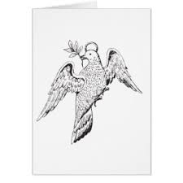
Deacons
Jewel for both Senior and Junior Deacons
A Deacon is a junior officer in the lodge. A lodge has two Deacons, the Senior Deacon (SD) and Junior Deacon (JD)
The principal duties of the SD are to conduct candidates around the Lodge and speak for them during the 2nd & 3rd Degree ceremonies, to attend the WM as needed and to carry his orders to the SW
The office and duties of JD are very similar to those of the SD - to attend the SW, and carry messages to the JW. His significant responsibility is to attend to Candidates in the 1st Degree.
The SD & JD jewels are a Dove bearing an olive branch, indicating their duties as messengers.

Stewards
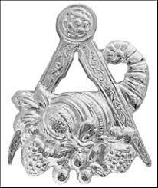
Jewel of the Stewards

Stewards fulfill a number of junior assistant roles. Some of their common duties could include:
- Acting as understudy to the SD & JD, in their absence.
- Stewards have a traditional role of arranging the tables, ensuring that glasses are filled, and that guests are accommodated - often extended to a general supervision and planning of catering and refreshments.
- Their Jewel is “Cornucopia” – the mythical “Horn of Plenty” within a pair of Compasses
The WM may appoint any number of Stewards, according to the size and requirements of his lodge, and in this respect the office is unique.
Newer members usually fill the office of Steward. The office may serve to dignify a useful member of the Lodge, or to establish precedence in the progression of officers.

Tyler
Jewel of the Tyler
The 'Tyler' is sometimes known as the 'Outer Guard' of the lodge. He guards the door (from the outside), with a drawn sword to see that only those who are qualified gain entry to lodge meetings. He has an important role in preparing candidates for their Degrees – if he gets this wrong, then the Candidates may well be sent out of the lodge for correction. The Tyler is traditionally responsible for preparing the lodge room before the meeting, and for storing and maintaining the equipment afterwards.
The Tyler may be a PM of the Lodge, but more commonly he may be a paid, fed, employed PM from another lodge.

Inner Guard

Jewel of the Inner Guard
The office of 'Inner Guard' (IG) is mandatory in UK lodges. His Jewel is Two crossed Swords. This position is commonly assigned to a fairly junior member, on the first rung of progression. He participates in and learns ceremonials, and is in the first progressive office leading to WM.
The task of guarding the door is shared with the 'Tyler' . The Inner Guard is inside the door, is armed with a poignard (a short dagger) which he presents to the WM during the 1st Degree.

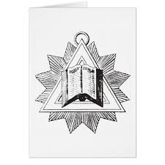
Chaplain
Jewel of the Chaplain
Each lodge will have a 'Chaplain' whose principal duty is to lead invocations before, during and after the lodge meeting, and to say grace while the lodge is at dinner. It is not required that Chaplains be clergymen, as invocations are non-denominational.
The Chaplains Jewel is “A Book within a Glory” – symbolising that the Holy Books of all religions originate in the realm of a Higher Power.

Director of Ceremonies
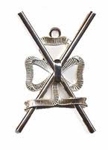
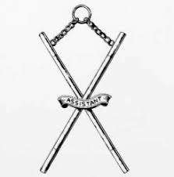
Jewel of Director of Ceremonies and Assistant Director of Ceremonies

A 'Director of Ceremonies' (DC) is appointed in every UGLE lodges. His jewel is two rods in saltire, tied with a ribbon. He may be supported by an Assistant Director of Ceremonies (ADC) whose Jewel is Two Rods in saltire without a ribbon.
The DC is responsible for the smooth flow of ritual, and in our lodge he also holds and manages Lodges of Instruction, Rehearsals, and the scheduling of Degree ceremonies.
His should be the only voice to prompt officers other than the WM if they forget their lines. He also directs and manages proceedings during the installation of a new Worshipful Master. He is responsible for forming processions and ensuring competency on those who undertake parts of ceremonies.
At the Festive Board which is overseen by the WM, the DC manages the event.

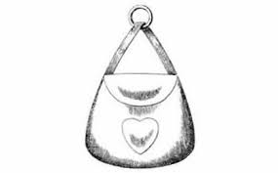
Almoner

Jewel of the Almoner
The 'Almoner' is responsible for the well-being of lodge members and their families. He receives and considers requests for assistance (whether financial or practical or otherwise) and confirms his recommendations with the lodge. He must maintain contact with sick or aged members and manage a discreet presence in the lives of widows of former members, so that the lodge may readily assist them should they find themselves in any particular need.
Almoners must understand local and national Masonic charities and the scope of their charitable work, so as to offer advice to those who might qualify for such assistance.
Organist
Jewel of the Organist
The 'Organist' provides appropriate musical accompaniment during lodge meetings. This may be through a pipe organ or electronic organ, a wider range of instruments or recorded or digital music systems

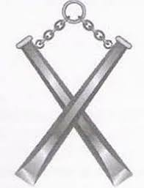
Mentor
Jewel of the Mentor
This Jewel is Two Chisels in Saltire, emphasising the advantages of education as pointed out by the symbolic use of the Chisel as a Working Tool in the 1st Degree. The Lodge Mentor is also the Membership Officer.

His duties include:
- encouraging members to present and introduce candidates for initiation and joining
developing learning styles and methods to suit the learning preferences of each member;
- arranging monthly social events to which prospective members and their families, as well as member’s and their families are invited;
- Running weekly training and development sessions for members who need additional tuition, especially Progression Officers, and arranging 1:1 sessions for members;
- Recommending members to the WM and DC, competently to participate in ceremonies;
- Encouraging senior members to undertake personal mentor duties with junior members; and
- Advising the WM and Secretary of matters relating to the Constitution and By-laws

Charity Steward

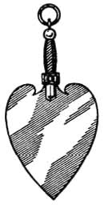
The Jewel of the Charity Steward (CS) is a Trowel appended to a collar.

All Craft lodges are charged with ensuring appropriate charitable donations by members towards good causes. The CS is responsible for encouraging the members to give generously and regularly. In Lodge, the CS may raise discussions about appropriate recipients of the lodge's charitable donations. His funds must be kept separately from Lodge Admin funds, and reported regularly to the Committee, through the Treasurer and to the Lodge.

Royal Arch Representative

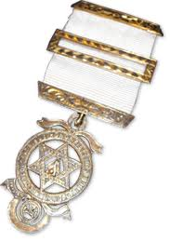
Jewel of Royal Arch

You may see members wearing this lapel Jewel at lodge. It is given to freemasons who join a Chapter of the “Holy Royal Arch of Jerusalem”, which was formerly considered the completion of the Craft 3rd Degree.

The white ribbon symbolises membership and members are called “Companions”. The principal officers of “Chapter” (as it is known) have jewels with coloured ribbons.

Chapter is the first of the “side degrees” to which Craft Freemasons may be invited. The side degrees are not superior degrees – and Craft Lodge membership is a requirement for all side-degree freemasons.

Some freemasons prefer to wait until they have passed through the WM chair before joining a Chapter. Others have sufficient time and resources to join a chapter earlier.

Lodge Committee

You will hear of matters being referred, by the Lodge or the WM, towards, or recommended by the Lodge Committee. This is the “Finance and General Purposes Committee” of the lodge, often referred to as the “GPC”. Our Lodge GPC usually meets on a Sunday before a Lodge meeting, or at other times, perhaps to interview prospective candidates for freemasonry.

A lodge may appoint a Committee of members to consider and reporting upon matters pending lodge approval such as financial matters, disciplinary issues and proposals for membership of the Lodge. A lodge directive may specifically refer any other matter to the GPC (or other Committee specially appointed in open Lodge) for consideration and report, with power to act within such limits as the Lodge may define.

Note that no Committee can be invested with any general executive powers. Any Committee may submit to the Lodge for consideration any matter which it may deem to be for the benefit of the Lodge. The Master ex officio shall belong to, and be entitled to preside over, every Committee of the Lodge.

Membership of our Lodge GPC is defined in our By-Laws – all PMs, both Wardens and two annually-elected members form the voting committee, and a quorum of 5 PMs is required for an effective meeting. Under normal circumstances, other members may attend either voluntarily or if they have been summoned to attend.

Provincial Officers

You will have noticed that the Aprons and Collars worn by members may be Light Blue or Dark Blue, Red or even Green.
- Light Blue identifies a Craft Lodge freemason up to the rank of IPM.
- Dark Blue demonstrates that some members have been appointed to “past ranks” within the Provincial Grand Lodge (PGL), in our case, PGL Sussex.
- Red indicates that a member has an active role to play in the running of our PGL.
- Green indicates a member of a Scottish Lodge accepted by UGLE.
- Note that the same symbols as used in our own lodge (and more) are used on the enamelled Jewels pendant to the collars of Provincial Officers.

This might appear to be a complicated subject to younger Mason, with Past Ranks and Active Ranks. Firstly, note that “Provincial Honours” are not automatically dispenses after a Brother has been WM. Generally some 7 years after being WM, PMs are considered for promotion to Provincial Rank by the Provincial Grand Master (PGM), and him alone.

The PGM takes into consideration the annual report of the various Lodge Secretaries and the Masters comments as these will show the active interest the Brother has taken in Lodge affairs and his attendance at Lodge and Committee meetings.

It is said that all Appointments to Provincial Rank, whether Active or Past have equal merit. It is also said to be an incentive for future members to give service to their Lodge after they have been WM. Under exceptional circumstances, members who have dedicated themselves to freemasonry without becoming WM may also receive Provincial Honours.

Provincial Grand Stewards wear the distinctive Red aprons and collars, which date back to 1731 when Grand Lodge decreed that the Grand Master, his Deputy and Wardens should line their aprons with blue silk, officers of private lodges with white silk, and Stewards for the year in Red silk.

